1.

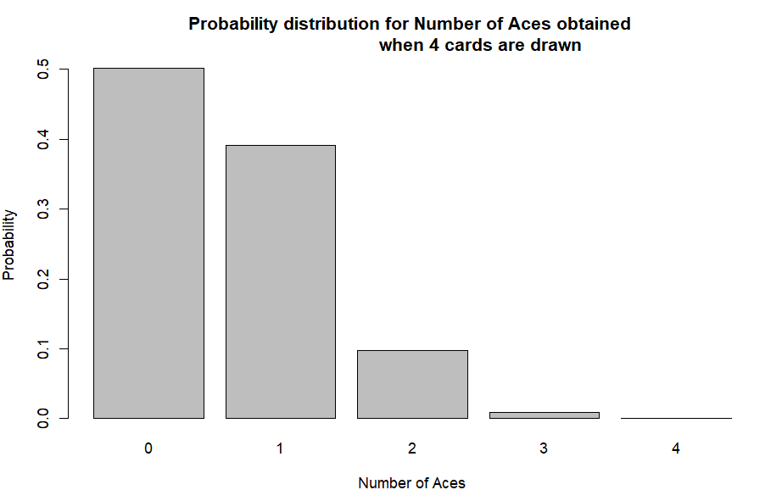

2.

a)

b)

3.

a)

b)

c)



d)

e)



4.

a)

5.

a)

b)

6.

a)

b)



c)



7.

8.

9.

a)



b)

c)

d)

e)

f)



g)



h)

